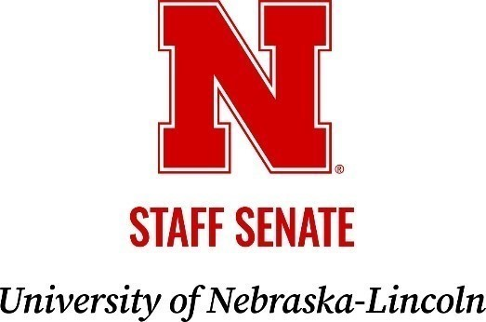
Meeting Agenda

Thursday, September 18, 2025 | 2:30 to 4 p.m.
Swanson Auditorium | Nebraska Union

Zoom: https://go.unl.edu/senatezoom

2:30 Call to Order
2:35 Presentation of Awards
2:40 Consent Agenda
2: 50 Officer Reports
President Jessie Brophy
VP Internal Affairs Jerri Harner
VP External Affairs Morgan Green McConnell
Secretary Treasurer Doug Pellatz
Executive Advisor Jordan Gonzales
Coordinator & Executive Secretary Joann Ross

3:10 Presentation by Ben Lennander, Asst VC for HR & Chief People Officer

3:40 Open Mic

4:00 Meeting Adjourned

