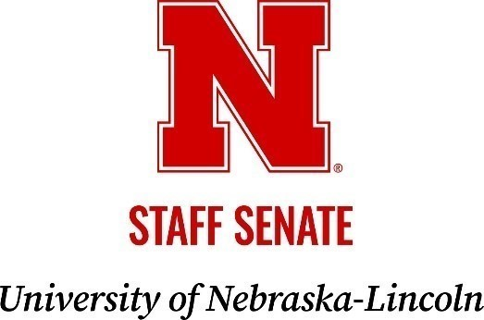
MEETING AGENDA

Thursday, November 13, 2025 | 2:30 to 4 p.m.
East Campus Union, Great Plains A

Zoom Meeting Information
https://go.unl.edu/senatezoom
Meeting ID: 964 9558 0889

2:30 p.m.

- Call to Order
- Consent Agenda
  - Approve the Meeting Minutes from September 18, 2025
  - Approve Committee Consent Reports

2:40 p.m.

- Recipient of the Presidential Citation Award for Excellence
  - Employee Assistance Program
  - University Housing and Dining

2:45 p.m.

- President Gold

3:30 p.m.

- Officer Report
  - President Brophy
  - Vice President for Internal Affairs Harner
  - Vice President for External Affairs Green McConnell
  - Secretary-Treasurer Pellatz
  - Executive Advisor Gonzales
  - Coordinator & Executive Secretary Ross

3:45 p.m. New Business / Open Mic

4:00 p.m.

- Adjournment

The next Staff Senate meeting is scheduled for Thursday, January 15, 2025, at the City Union, Swanson Auditorium
---------------------------------------------------------------------------

The University of Nebraska is a public land-grant institution with campuses and programs across the State that reside on the past, present, and future homelands of the Pawnee, Ponca, Oto-Missouria, Omaha, Dakota, Lakota, Arapaho, Cheyenne, and Kaw Peoples, as well as the relocated Ho Chunk (Winnebago), Iowa, Sac and Fox Peoples.

