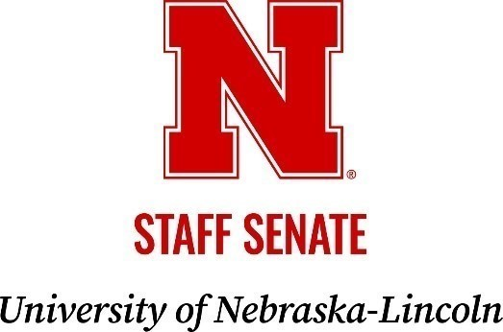
MEETING AGENDA

Thursday, January 15, 2026 | 2:30 to 4 p.m.
East Campus Union, Prairie Suite (3rd Floor)

Zoom Meeting Information
https://go.unl.edu/senatezoom
Meeting ID: 964 9558 0889

2:30 p.m.

1. Call to Order
2. Consent Agenda
  - Approve the Meeting Minutes from November 13, 2025
  - Approve Committee Consent Reports

2:40 p.m.

- Officer Reports
  - President Brophy
  - Vice President for Internal Affairs Harner
  - Vice President for External Affairs Green McConnell
  - Executive Advisor Gonzales

- Committee Reports

3:00 p.m.

- Old Business
- Task Force on Workplace Culture and Engagement - Executive Advisor Gonzales
- Townhall Feedback Report – President Brophy

3:15 p.m.

- New Business/Open Mic

3:45 p.m.

- Adjourn early to attend President Gold/Interim Chancellor Ankerson’s Listening Session

The next Staff Senate meeting is scheduled for Thursday, March 12, 2026, at the East Union, Great Plains Room A.

